GO WITH THE FLOW
Code Bible & Handoff Guide
How the Laboratory Control Suite GUI, the Arduino sketch and the pressure sensors work, how to run them, and what to change next
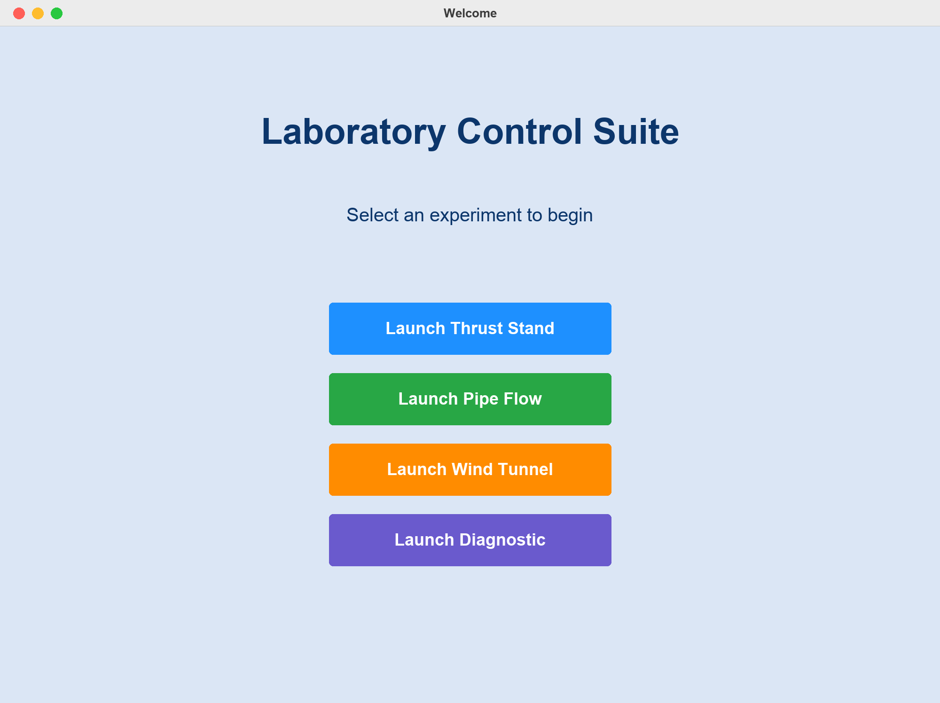
UMD Vertically Integrated Projects · Go With The Flow team
Prepared by Talia Itskowitz · October 1, 2026
Repository: github.com/TerrenceCPierce/go-with-the-flow

Contents

If the table of contents is empty, right-click it and choose Update Field (Word may also offer to update it when the file opens).

1. Start here
Go With The Flow is a desktop app plus one Arduino program. Together they read air-pressure sensors and save the readings to a spreadsheet file (CSV) for four lab setups: the Thrust Stand, Pipe Flow, Wind Tunnel and a live Diagnostic view. The app is written in Python. It sends short text commands to the Arduino over a USB cable. The Arduino reads up to 8 pressure sensors and sends the numbers back.
This manual describes the code as of 1 October 2026, including changes in GUI.py that are on the handoff laptop but not yet pushed to GitHub (see Section 9).

How to read it
- Just running experiments? Read Section 7 (what each window does) and Section 11 (step-by-step). Keep Section 12 (troubleshooting) handy.
- Need to understand or change the code? Read top to bottom. Each section starts with the plain-English idea, then shows the code.
- Taking over as maintainer? Also read Section 9, which covers known issues, a handoff checklist and suggested future work.
The repository: github.com/TerrenceCPierce/go-with-the-flow (UMD Vertically Integrated Projects, Go With The Flow team). Contributors in the git history: Terrence Pierce, Talia Itskowitz and vpatel-7.

The five things that matter
File | What it is
GUI.py | The whole app: welcome screen, the four experiment windows, serial communication, plots, table and CSV saving
combined_arduino_protocol_copy_20260410081734.ino | The Arduino program the app expects. Upload this one to the board.
requirements.txt | The exact Python library versions the app needs
Large_Teardrop.webp, Small_Teardrop.webp, Half_Sphere.png | Pictures of the Wind Tunnel test objects
GUI_Landing_Page.py | An optional alternative launcher (GUI.py already has its own welcome screen)

Everything else in the repository is an old prototype, a test sketch or build output (see Section 3).
Screenshots in this manual were made by running the real GUI.py against a simulated Arduino on the handoff laptop, so the windows and plots are real but the numbers are made up. Each window was rendered from the app's live layout.

2. System overview
The system has three layers: the Python app on a laptop, an Arduino connected by USB, and up to 8 DPS310 pressure sensors connected to the Arduino through an I2C multiplexer. Everything the app knows about the sensors arrives as lines of text over the USB cable.
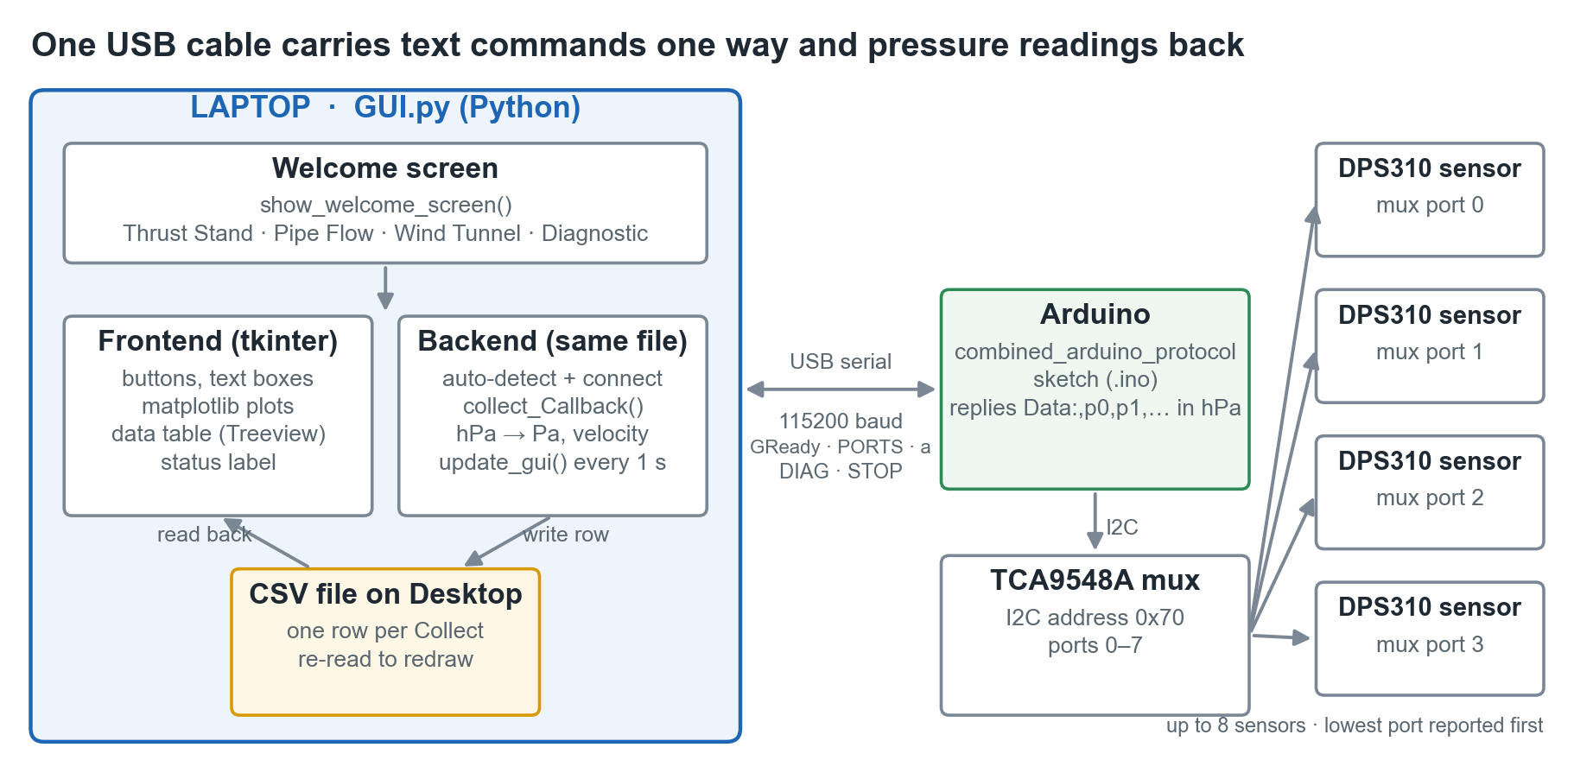
The parts of the system and how they connect

What happens in one measurement
- A team member types the experiment inputs (position, thrust or drag) and clicks Collect.
- GUI.py sends the single letter a to the Arduino.
- The Arduino switches the multiplexer to each sensor in turn, reads its pressure, and sends back one line, for example Data:,1012.4031,1012.4002.
- GUI.py converts the values from hPa to Pa, appends a row to the CSV file on the Desktop and redraws the plots and table.

The four experiment windows
Window | Sensors used | You type in | Plots | Saves to
Thrust Stand | 2 (pitot, ambient) | Thrust (g), position (mm) | Pressure vs position, velocity vs position | arduino_data<date_time>.csv
Pipe Flow | 4 | Data collection number | One pressure plot per sensor (2×2 grid) | pipe_flow_<date_time>.csv
Wind Tunnel | 2 (ambient, inside) | Object type, drag force (N), data number | Ambient pressure, inside pressure | wind_tunnel_<date_time>.csv
Diagnostic | All connected | Nothing | Live pressure vs time, last 60 s | Nothing (not saved)

3. Repository map
Only GUI.py and the combined_arduino_protocol sketch are in active use. The other files are kept for history or testing and are safe to ignore.
Path | Status | What it is
GUI.py | Live | The app (1,628 lines). Run it with python GUI.py.
combined_arduino_protocol_copy_20260410081734/ | Live | The Arduino sketch that matches the app. Arduino IDE needs every sketch in a folder with the same name, which is why it sits in a folder.
requirements.txt | Live | Exact library versions, installed with pip install -r requirements.txt
Large_Teardrop.webp, Small_Teardrop.webp, Half_Sphere.png | Live | Object pictures for the Wind Tunnel window. They must be in the same folder as GUI.py.
GUI_Landing_Page.py | Optional | An older welcome screen. It closes itself and opens the chosen experiment in its own window.
multiplexer_arduino_code/dps310_multi_test/dps310_multi_test.ino | Test tool | A standalone sketch that scans all 8 multiplexer ports and prints each sensor's temperature and pressure. Use it to check wiring.
multiplexer_arduino_code/dps310_multi_test/arduino_auto_detect | Legacy | A Python prototype (no file extension) of the automatic Arduino detection now built into GUI.py
i2c_background_modified/i2c_background_modified.ino | Legacy | The previous experiment sketch. It only returns 2 sensors and does not understand PORTS or DIAG. Do not use it with the current app.
SerialComm.py | Legacy | The first prototype (Feb 2025): a text-only script with port COM5 hard-coded
3.25_test1.py | Legacy | An early mock-up of the Thrust Stand window, with no logic
Test Data/arduino_data2025-04-04_09-41-00.csv | Sample | A real Thrust Stand run from April 2025 (older column names)
GUI_Landing_Page.spec, ThrustStandExperiment.spec | Build | PyInstaller recipes used to make the old .exe and .app files (see Section 10)
build/, dist/, __pycache__/, .venv/ | Generated | Build output, compiled Python and a local Python environment. They can all be regenerated and should not be in git.

.gitignore only ignores *.csv, which keeps experiment data off GitHub. It should also ignore the generated folders above and .DS_Store.

4. The Arduino sketch
The Arduino does three things. It finds every pressure sensor when it starts, waits for a text command from the laptop, and replies with readings. The file is combined_arduino_protocol_copy_20260410081734.ino (169 lines).

The hardware it expects
- An Arduino board connected to the laptop by USB. The sketch uses only standard features, so any common board works. Record which board the lab uses (see the handoff checklist).
- Adafruit DPS310 sensors. Each one measures absolute air pressure (and temperature) and reports pressure in hectopascals (hPa). 1 hPa = 100 Pa; room air is about 1013 hPa.
- A TCA9548A I2C multiplexer at address 0x70. Every DPS310 has the same I2C address, so two cannot share one bus. The multiplexer has 8 numbered ports (0–7), each with its own sensor. The Arduino switches to one port at a time.
Port order matters. The sketch reports sensors from the lowest port number to the highest, and the app gives each reading its meaning by that order. On the Thrust Stand, the lowest-numbered port is treated as the pitot (moving-air) sensor and the next one as ambient. Plugging sensors into different ports can silently swap them.

Libraries
In the Arduino IDE Library Manager, install Adafruit DPS310. It also installs Adafruit BusIO and Adafruit Unified Sensor. Wire.h (I2C) is built in.

Start-up: setup() and initSensors()
The sketch runs at power-up, and also whenever the app opens the USB port, because opening the port resets most Arduinos. It starts serial at 115200 baud and the I2C bus at 400 kHz. It then tries all 8 multiplexer ports and remembers the ones where a sensor answers.
void initSensors() {
numValidPorts = 0;
for (int i = 0; i < MAX_PORTS; i++) { // MAX_PORTS = 8
tcaselect(i); // switch the multiplexer to port i
delay(50);
if (dpsArray[i].begin_I2C()) { // is a DPS310 answering?
validPorts[numValidPorts++] = i; // remember the port number
dpsPressureArray[i] = dpsArray[i].getPressureSensor();
dpsArray[i].configurePressure(DPS310_64HZ, DPS310_64SAMPLES);
dpsArray[i].configureTemperature(DPS310_64HZ, DPS310_64SAMPLES);
Serial.print("Sensor found on TCA port ");
Serial.println(i);
}
}
...
}
tcaselect(i) writes one byte to the multiplexer with only bit i set (1 << i). That connects port i and disconnects the others.

Two speed settings
The DPS310 can trade speed for noise. The sketch switches between two settings:
Setting | Function | Rate × oversampling | Used for
Experiment | configExperiment() | 64 Hz × 64 samples | Single, averaged, low-noise readings when Collect is clicked
Diagnostic | configDiagnostic() | 128 Hz × 1 sample | Fast, noisier streaming for the live Diagnostic plot

Listening for commands: loop() and processCommand()
loop() runs forever. Each time it checks whether a line of text has arrived over USB and, if so, passes it to processCommand(). In Diagnostic mode it also sends a reading every 50 ms (20 per second).
void loop() {
if (Serial.available()) {
String cmd = Serial.readStringUntil('\n');
processCommand(cmd);
}
if (currentMode == DIAGNOSTIC) {
if (millis() - lastDiagTime >= DIAG_INTERVAL_MS) { // 50 ms
lastDiagTime = millis();
// print one "Data:,p0,p1,..." line
}
}
}
The sketch is always in one of three modes: IDLE, EXPERIMENT or DIAGNOSTIC. The five commands are listed in Section 5.
void processCommand(String cmd) {
cmd.trim();
if (cmd == "GReady") { // handshake from the app
currentMode = EXPERIMENT;
configExperiment();
Serial.println("Arduino Ready 1");
} else if (cmd == "a") { // take one reading
...
delay(1000);
Serial.println("Arduino Data Ready");
delay(100);
sendDataLine();
} else if (cmd == "DIAG") { // start live streaming
currentMode = DIAGNOSTIC;
configDiagnostic();
} else if (cmd == "STOP") { // stop live streaming
currentMode = IDLE;
configExperiment();
} else if (cmd == "PORTS") { // which ports have sensors?
Serial.print("Ports:,"); // e.g. "Ports:,0,1,3"
...
}
}

Producing a reading: sendDataLine()
void sendDataLine() {
Serial.print("Data:,");
for (int j = 0; j < numValidPorts; j++) {
int port = validPorts[j];
tcaselect(port);
delay(20);
sensors_event_t ev;
dpsPressureArray[port]->getEvent(&ev);
if (j > 0) Serial.print(",");
Serial.print(ev.pressure, 4); // hPa, 4 decimal places
}
Serial.println();
}
With two sensors the output looks like Data:,1013.2541,1013.0127. The values are in hPa; the app multiplies them by 100 to get Pa.

Uploading the sketch
- Install the Arduino IDE (arduino.cc/en/software) and the Adafruit DPS310 library.
- Open combined_arduino_protocol_copy_20260410081734.ino.
- Choose the board under Tools → Board and the USB port under Tools → Port, then click Upload.
- Optional check: open Tools → Serial Monitor at 115200 baud. You should see Sensor found on TCA port 0, …, Total sensors: N and Arduino Ready 1. Type a and press Enter to get a Data:, line.
- Close the Serial Monitor before starting the app. Only one program can use the USB port at a time.
The board keeps the sketch after it is unplugged. Upload again only if the sketch changes or the board is replaced.

5. Serial communication
The laptop and the Arduino exchange plain lines of text over USB at 115200 baud, each ending with a newline. The laptop sends a short command and the Arduino answers with a line that starts with a fixed tag. Python does this with the pyserial library (import serial).

The protocol
Laptop sends | Arduino replies | Sent when | Meaning
GReady | Arduino Ready 1 | Connect (Thrust Stand, Pipe Flow, Wind Tunnel) | Handshake; also puts the sensors in experiment mode
PORTS | Ports:,0,1,3 | Connect | Which multiplexer ports have a sensor, lowest first
a | Arduino Data Ready, then about 1 s later Data:,p0,p1,… | Collect | One averaged reading from every sensor, in hPa
DIAG | Diagnostic mode ON, then a Data:,… line every 50 ms | Diagnostic → Start | Start fast live streaming
STOP | Diagnostic mode OFF | Diagnostic → Stop | Stop streaming

At start-up the Arduino also prints Initializing sensors..., a Sensor found on TCA port N line per sensor and Total sensors: N. The app ignores lines it does not recognise, so these are harmless.

Finding the port
Each computer names the Arduino's USB connection differently: COM3, COM4, … on Windows and something like /dev/cu.usbmodem1101 on a Mac. Connect finds it automatically by checking each USB device's description for words used by Arduino boards and their USB chips:
def find_arduino_port():
ports = serial.tools.list_ports.comports()
for port in ports:
desc = (port.description or "").lower()
if any(k in desc for k in ["arduino", "usb serial", "usb to uart",
"ch340", "cp210", "silicon labs"]):
return port.device
return None
It returns the first match, so if two Arduinos (or other USB-serial devices) are plugged in it may pick the wrong one. A port typed as a bare number such as 5 becomes COM5. In the three experiment windows, Connect always auto-detects and overwrites the Port box. Only the Diagnostic window uses what you type.

Connecting: arduinoConnect_Callback()
arduino = serial.Serial(port=port, baudrate=115200, timeout=1.0)
time.sleep(2) # opening the port resets the Arduino; let it boot
arduino.reset_input_buffer() # discard the start-up messages
arduino.write("GReady\n".encode())
# up to 10 tries: read a line, look for "Ready", otherwise resend GReady
query_ports() # send PORTS, parse "Ports:,0,1" into detected_ports
if detected_ports:
newfile_Callback() # start a fresh CSV whose headers name the real ports
arduino_status_var.set(f"Connected to {port}")

Taking a reading: collect_Callback()
This runs when you click Collect. It is the core of every experiment window.
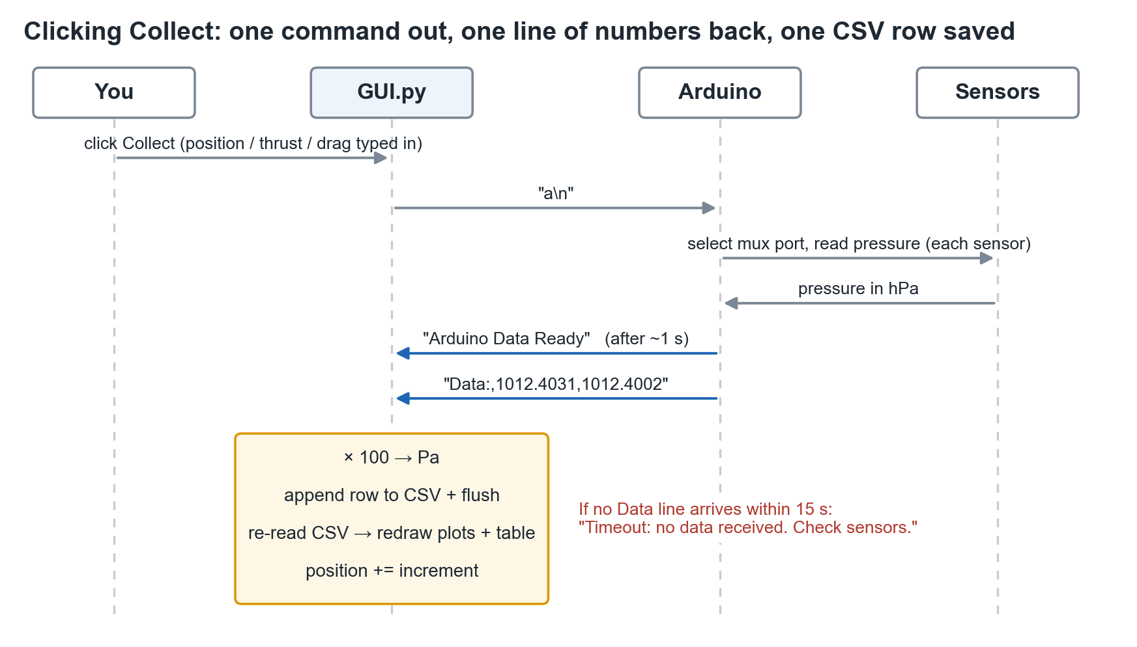
What happens when you click Collect
- Check that the app is connected and a CSV file is open.
- Clear any leftover bytes in both directions.
- Read the position or data number (and thrust or drag) from the input boxes.
- Send a.
- For up to 15 seconds, read lines until one starts with Data:,.
- Split on commas, convert each value to a number and multiply by 100 (hPa → Pa).
- Append a row to the CSV, flush it to disk, re-read the CSV and redraw the plots and table.
- Add the increment to the position or data number (see Section 7).
if line.startswith("Data:,"):
pressure_values = line.split("Data:,", 1)[1].split(",")
pitot_press = float(pressure_values[0]) * 100 # hPa -> Pa
ambient_press = float(pressure_values[1]) * 100
writer.writerow([x_pos, str(pitot_press), str(ambient_press), thrust])
file_handle.flush() # saved to disk immediately
df = pd.read_csv(file_handle.name)
refresh_all(df) # redraw plots + table
If no Data:, line arrives in time, the status reads "Timeout: no data received. Check sensors."

Live streaming: the Diagnostic window
The Diagnostic window skips GReady and PORTS. Start sends DIAG, then poll_arduino() runs every 100 ms. Each run reads one line, converts it to Pa, adds it to a rolling 60-second buffer and redraws the plot. Stop sends STOP.
Known limitation: the Arduino sends 20 lines per second but the app reads at most 10. Unread lines queue up, so in a long session the plot falls further and further behind real time. Stopping and starting again clears the backlog. A fix is in Section 9.

6. Inside GUI.py: frontend and backend
The whole app is one file. The frontend (windows, buttons, plots, table) and the backend (serial communication, CSV writing, calculations) live in the same functions. Each experiment window is one large function that builds its screen and defines its own button handlers inside itself.

Libraries and what they do
Library | Role in the app
tkinter / ttk | Python's built-in window toolkit: windows, labels, text boxes and the data table (ttk.Treeview)
tkmacosx.Button | Coloured buttons; plain tkinter buttons ignore background colours on macOS
customtkinter | Only the on/off auto-increment switch (CTkSwitch)
matplotlib + FigureCanvasTkAgg | Draws the graphs and embeds them in the tkinter windows
pyserial | Talks to the Arduino over USB
pandas | Reads the CSV back in to refresh the table and plots
numpy | The velocity calculation
Pillow (PIL) | Loads and shrinks the Wind Tunnel object pictures
csv, datetime, os, webbrowser | Write the CSV, timestamp file names, find the Desktop, open the Lab Details link

Map of the file
Lines | Function | What it builds
17–20 | constants | AIR_DENSITY = 1.298351265 kg/m³, the Lab Details Google Drive link, four plot colours
23–36 | launch_thrust_stand() etc. | Four short public entry points, one per window; GUI_Landing_Page.py imports these
43–219 | _launch_diagnostic_window | Diagnostic: live pressure vs time
226–655 | _launch_pipe_flow_window | Pipe Flow: four plots in a 2×2 grid
660–1144 | _launch_wind_tunnel_window | Wind Tunnel: two pressure plots, object picker and drag input
1150–1583 | _launch_experiment | Thrust Stand: pressure and velocity vs position
1590–1625 | show_welcome_screen | The welcome window with four launch buttons
1628 | if __name__ == "__main__" | Running python GUI.py opens the welcome screen

The shape of every experiment window
The three experiment windows follow the same pattern. Learn one and you know all three.
def _launch_pipe_flow_window(master):
master.withdraw() # hide the welcome screen
root = tk.Toplevel(master) # open a new window on top

# 1. STATE - variables shared by the handlers below
pos_var = tk.StringVar(value="0") # linked to a text box: .get() / .set()
arduino = None # the open serial connection
file_handle = None # the open CSV file
CSV_COLS = [...] # column headers

# 2. HANDLERS - what each button does
def on_close(): ... # close serial + file, show welcome again
def newfile_Callback(): ... # start a new CSV
def auto_connect_arduino(): ... # find the port, then arduinoConnect_Callback()
def collect_Callback(): ... # send "a", parse, save, refresh
def refresh_plots(df): ... # redraw the matplotlib graphs
def refresh_table(df): ... # refill the table
def update_gui(): ... # re-read the CSV every 1 s

# 3. LAYOUT - create widgets and place them on a grid
Button(root, text="Collect", command=collect_Callback).grid(row=3, column=2)

# 4. START
newfile_Callback()
update_gui()
Terms you will meet in the code:
- tk.StringVar / tk.IntVar: a variable linked to a widget. When someone types in a text box, the linked variable updates automatically.
- nonlocal: the handlers are defined inside the window function, so they need nonlocal arduino (for example) to change that function's variables.
- .grid(row=…, column=…): places a widget on an invisible grid. Each window uses 4 columns × 4 rows: a top bar, two rows of graphs and table, and a bottom control row.
- root.after(1000, update_gui): asks tkinter to run update_gui again in 1000 ms. This is how the app repeats work without a loop that would freeze the window.
- root.protocol("WM_DELETE_WINDOW", on_close): makes the window's close button do the same clean-up as Exit.

Where the data lives
The CSV file on disk is the single source of truth. After every Collect, and once a second through update_gui(), the app re-reads the whole file with pd.read_csv and redraws the plots and table from it. Each row is flushed to disk immediately, so if the app crashes everything collected so far is already saved.

New File and file names
newfile_Callback() closes the current CSV, rebuilds the table with the current headers and creates a new file named with the date and time. It saves to the Desktop; if there is no Desktop folder it uses the home folder, and if that is not writable, the folder the app was started from.
timestamp = datetime.now().strftime("%Y-%m-%d_%H-%M-%S")
filename = f"pipe_flow_{timestamp}.csv"
save_dir = os.path.join(os.path.expanduser("~"), "Desktop")
It runs once when a window opens, and again after Connect if the Arduino reported its ports, so that the headers name the real ports (for example MUX Port 2 - Pressure (Pa)). This means each session leaves one empty CSV (headers only) next to the real one. See Section 9.

The physics: velocity from pressure (Thrust Stand)
The Thrust Stand computes air speed from the difference between the pitot reading (first sensor) and the ambient reading (second sensor), using Bernoulli's equation:
V = √( 2 × (P_pitot − P_ambient) / ρ ), with ρ = 1.298 kg/m³
AIR_DENSITY = 1.298351265 # kg/m^3

velocity = np.sqrt(
np.maximum(0, 2 * (dataframe[press_col] - dataframe[amb_col]) / AIR_DENSITY)
)
np.maximum(0, …) sets negative differences to zero, because sensor noise can make the pitot reading slightly lower than ambient. The density is a fixed number and is not adjusted for the day's temperature or air pressure.

Window flow
When an experiment opens, the welcome screen hides itself (withdraw). It comes back (deiconify) when that window is closed. Each launch_* function also works without a welcome screen (master=None): it creates its own hidden root window, which is how GUI_Landing_Page.py uses them.

No background threads
Everything runs on tkinter's single main thread. While Connect (about 3–6 s) or Collect (about 1–2 s, up to 15 s on a timeout) waits for the Arduino, the window does not respond to clicks. This is expected and is not a crash. Section 9 explains how to fix it.

7. GUI features and how they map to the experiments
Every experiment window has the same layout: plots on the left, the data table on the right, connection status and experiment inputs along the bottom, and big Collect and New File buttons at the bottom right. The CSV saved on the Desktop always matches the table on screen.

Controls shared by every experiment window
Control | What it does
Lab Details | Opens the lab procedure document on Google Drive in your web browser. That document, not this manual, is the reference for the physical setup.
Exit | Closes the serial connection and the CSV file and returns to the welcome screen. The window's close button does the same.
Arduino Status | Red = not connected or an error; green = Connected to <port>. Problems such as timeouts also appear here.
Port | Filled in automatically by Connect
Connect | Finds the Arduino, does the handshake, asks which sensor ports are in use and starts a new CSV with matching column names
Collect | Takes one reading from every sensor and adds one row to the table, plots and CSV
New File | Starts a new CSV (and clears the table and plots). Use it between runs, for example when you change thrust setting or test object.
Auto-increment switch | Controls how the position or data number changes after each Collect (details per window below)

The welcome screen
Run GUI.py and this window appears. Each button opens one experiment and hides the welcome screen until that experiment is closed.
Welcome screen (Laboratory Control Suite)

Thrust Stand
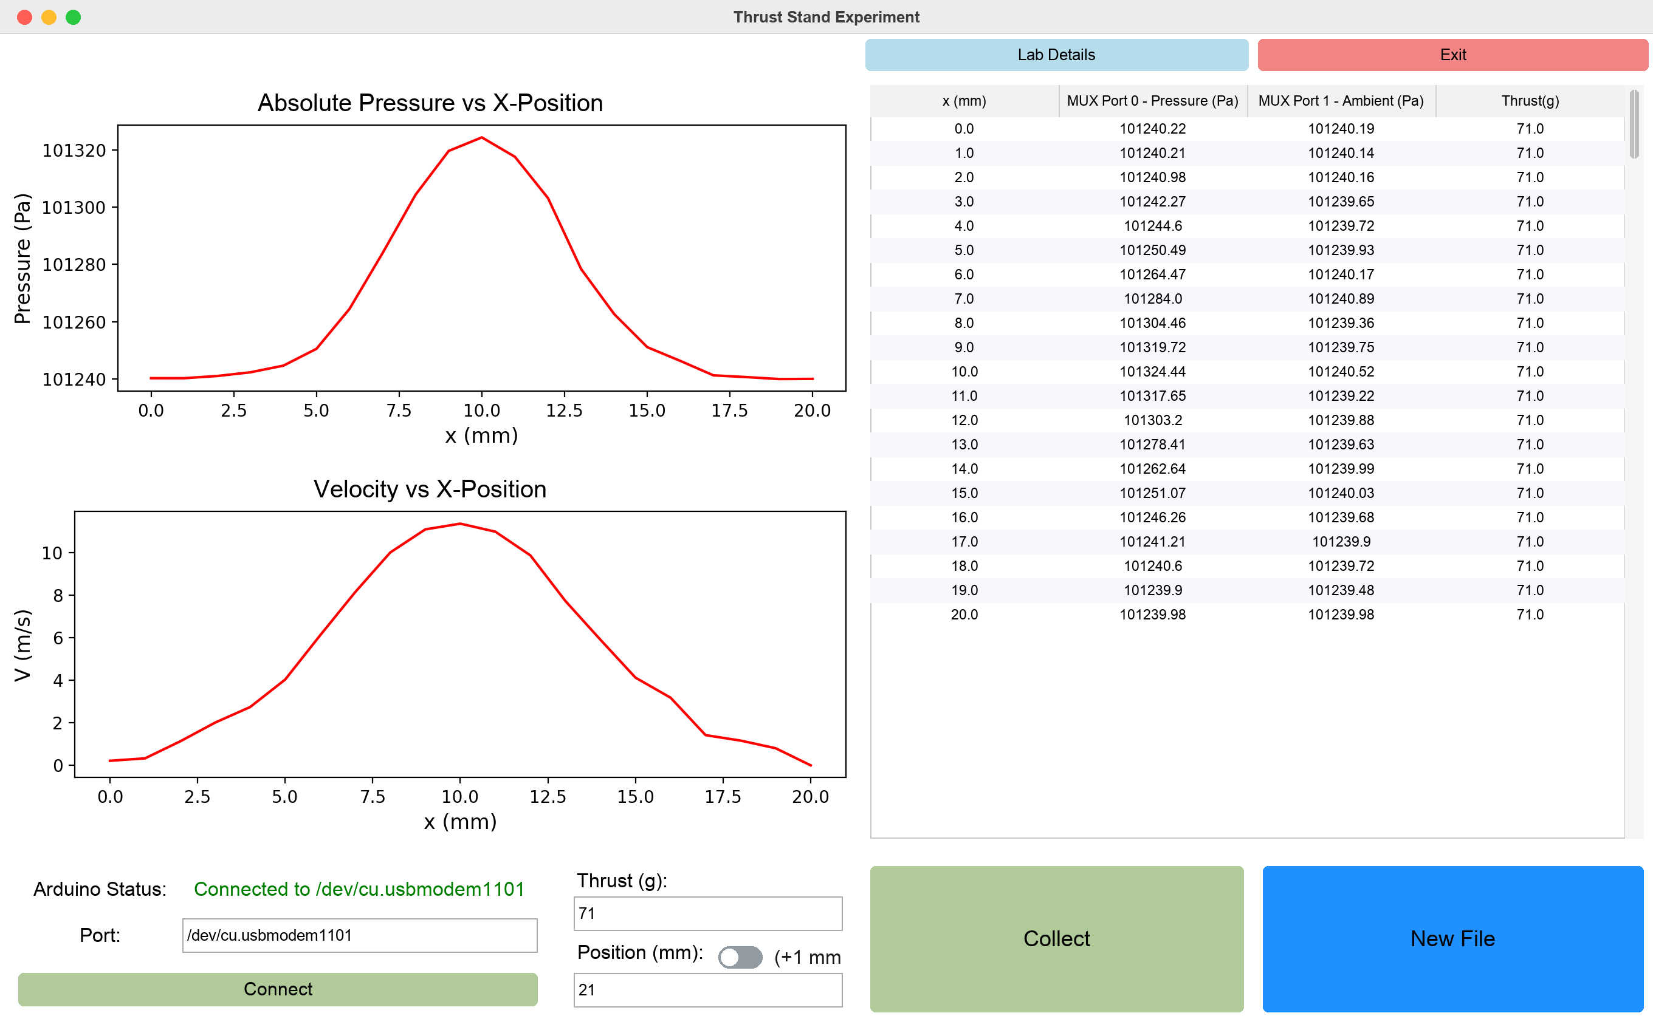
Thrust Stand window after a 21-point traverse (simulated data)
What it measures. The app records two pressures at each probe position: the pitot sensor (first port) and ambient air (second port). It also records the thrust you type in. From the difference it calculates air velocity, so a run gives a velocity profile across the airflow at one thrust setting.
Input or output | Details
Thrust (g) | Typed in by hand from the thrust stand's readout. It is copied into every row until you change it.
Position (mm) | The probe position for the next reading. It goes up automatically after each Collect.
Increment switch | Off = +1 mm per Collect (label "(+1 mm)"); on = +2 mm. Position always advances. To repeat a position, retype it before clicking Collect.
Top plot | Absolute pressure at the pitot sensor vs position (Pa)
Bottom plot | Velocity vs position (m/s), from the formula in Section 6
CSV columns | x (mm), MUX Port A - Pressure (Pa), MUX Port B - Ambient (Pa), Thrust(g)

Typical run. Connect → type the thrust → set the position to the first point (for example 0) → Collect, move the probe by the increment, Collect, and so on → New File before changing thrust.

Pipe Flow
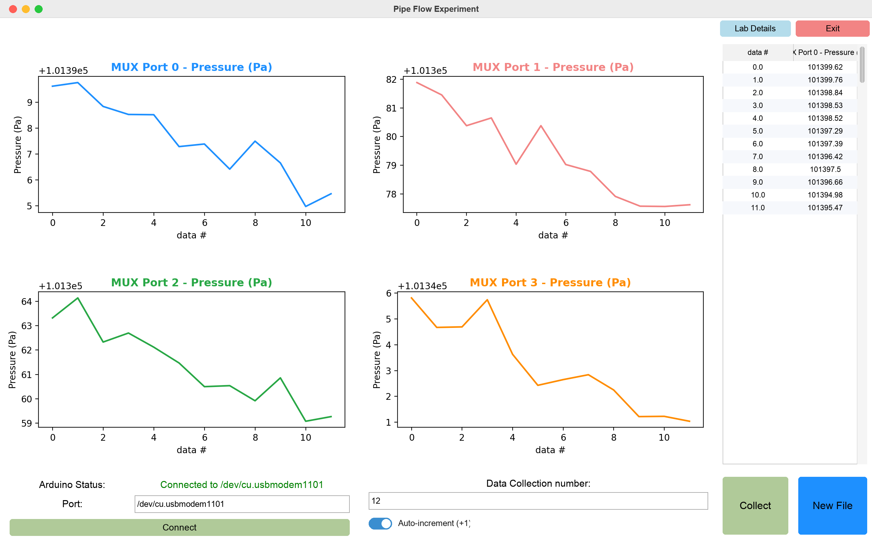
Pipe Flow window after 12 readings from 4 sensors (simulated data)
What it measures. Four pressure sensors are read together at each Collect, and each gets its own plot against the data number. It is designed for comparing the pressure at four points at the same moment, for example along a pipe.
Input or output | Details
Data Collection number | A label for the row. It goes up by 1 after each Collect while the switch is on.
Auto-increment (+1) | On (default) = +1 per Collect; off = the number stays the same
Four plots | One per sensor, titled with its multiplexer port, pressure (Pa) vs data number
CSV columns | data # plus one MUX Port N - Pressure (Pa) column per sensor

Use exactly 4 sensors. The Pipe Flow code always writes 4 pressure values per row and fills missing sensors with 0. If fewer than 4 sensors are connected, the column headers no longer line up with the data and the table and plots show the wrong numbers. With more than 4, the extra sensors are ignored. Check with the Diagnostic window first. See Section 9.

The data table is narrow in this window. Widen the window or scroll to see all columns; the CSV file always contains all of them.

Wind Tunnel
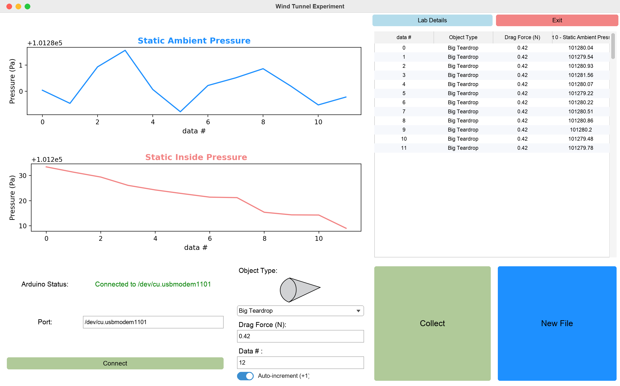
Wind Tunnel window with the Big Teardrop selected (simulated data)
What it measures. For each test object, the app records the drag force you type in from the force readout, the static ambient pressure (first port) and the static pressure inside the test section (second port).
Input or output | Details
Object Type | Big Teardrop, Small Teardrop or Half-Sphere. A picture of the selected object appears above the menu.
Drag Force (N) | Typed in by hand. It is copied into every row until you change it, so update it before each Collect.
Data # | Row label; +1 after each Collect while the switch is on
Plots | Static ambient pressure and static inside pressure (Pa) vs data number
CSV columns | data #, Object Type, Drag Force (N), MUX Port A - Static Ambient Pressure (Pa), MUX Port B - Static Inside Pressure (Pa)

Typical run. Connect → choose the object → for each wind speed or condition, type the drag force and click Collect → New File (or just change Object Type) for the next object. Object Type is saved in every row, so several objects can share one file.

Diagnostic
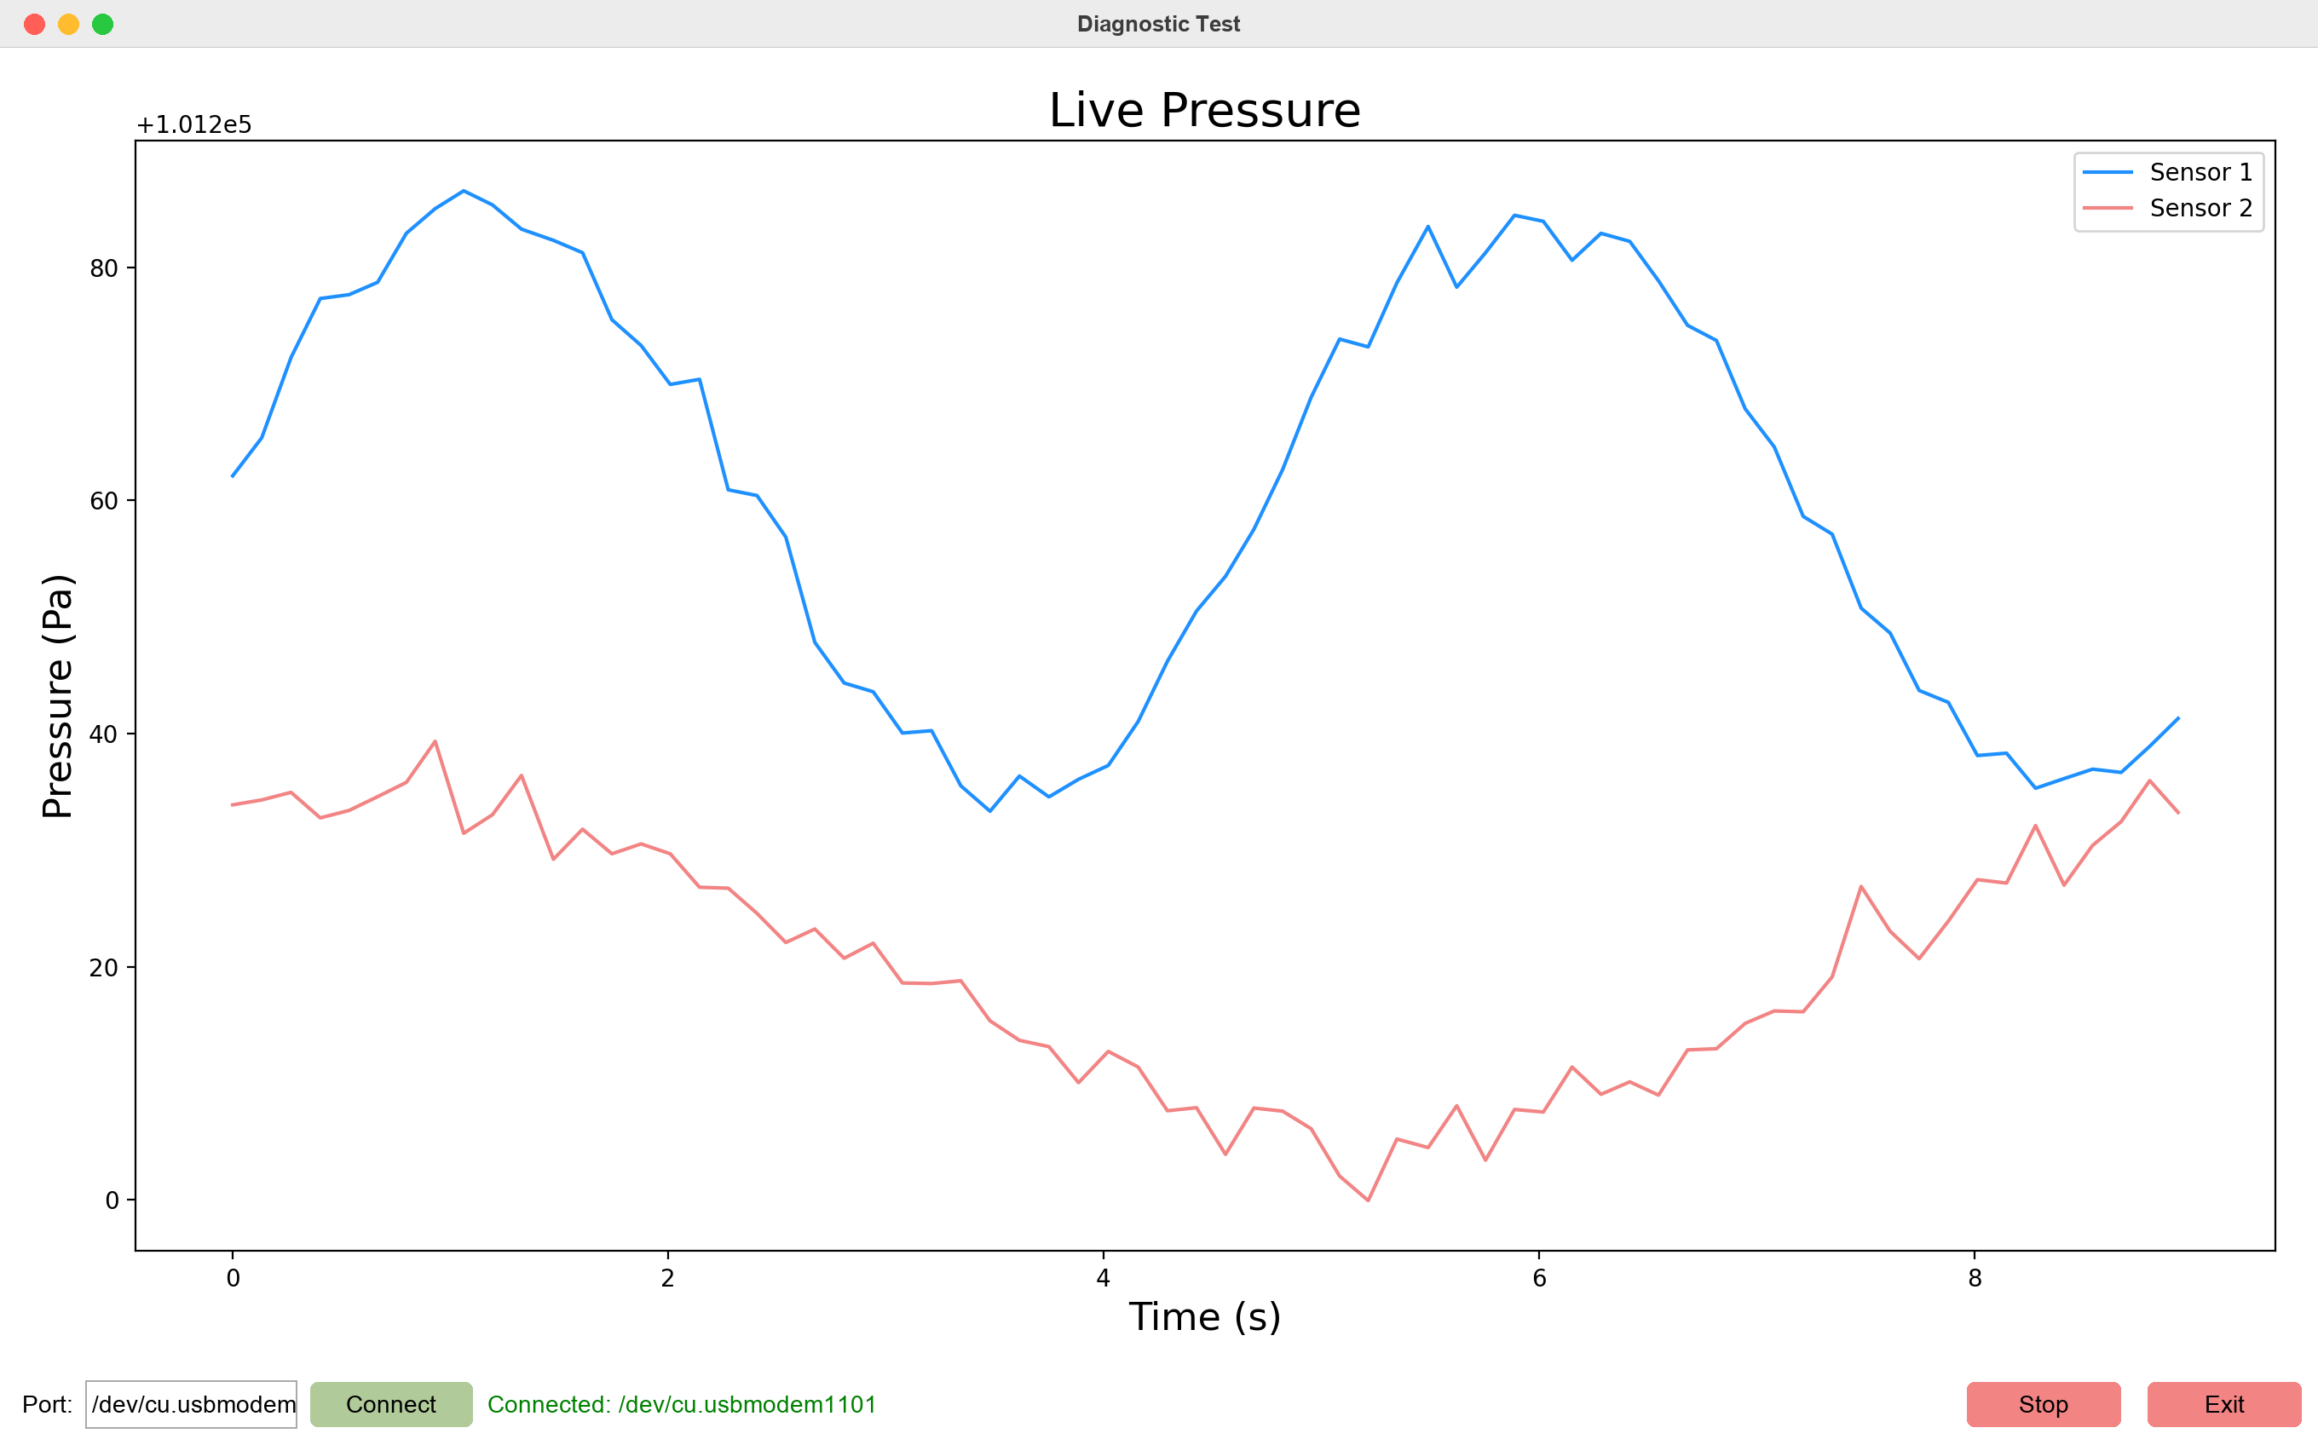
Diagnostic window streaming two sensors (simulated data)
What it is for. A quick health check before an experiment. It shows every connected sensor live (pressure vs time, last 60 seconds, about 10 updates per second) so you can see whether each sensor responds, for example by gently blowing across it or covering it. Nothing is saved.
- Type the port, or leave the box empty to auto-detect, then click Connect.
- Click Start. The button turns red and reads Stop.
- Check that there is one line per sensor and that each one reacts.
- Click Stop, then Exit to go back to the welcome screen before opening an experiment.
Sensors are numbered 1, 2, 3… in port order, so "Sensor 1" is the lowest-numbered multiplexer port.

8. Data output
Every Collect adds one row to a CSV file on the Desktop. CSV is plain text with commas between columns; Excel, Google Sheets, MATLAB and Python all open it directly. Pressures are always in pascals (Pa) and are absolute pressures, so values near 101,000 Pa are normal. What matters is the difference between sensors.

File names
Window | File name pattern | Example
Thrust Stand | arduino_data<YYYY-MM-DD_HH-MM-SS>.csv | arduino_data2026-10-01_14-30-05.csv
Pipe Flow | pipe_flow_<YYYY-MM-DD_HH-MM-SS>.csv | pipe_flow_2026-10-01_14-30-05.csv
Wind Tunnel | wind_tunnel_<YYYY-MM-DD_HH-MM-SS>.csv | wind_tunnel_2026-10-01_14-30-05.csv

Each window opening creates two files: an empty one (headers only) when the window opens and the real one after Connect. Use the newer, larger file and delete the empty one.
Where the file goes: the Desktop. On Windows PCs where OneDrive manages the Desktop, the app may not find it and will save to your user folder (C:\Users\<you>) instead. The terminal window shows the exact path on a line beginning Writing data to.

Example (Thrust Stand)
x (mm),MUX Port 0 - Pressure (Pa),MUX Port 1 - Ambient (Pa),Thrust(g)
0,101240.22,101240.19,71
1,101240.21,101240.14,71
2,101240.98,101240.16,71

Analysing the data in Python
Velocity is not saved in the CSV; the app calculates it only for the plot. To get it back:
import numpy as np
import pandas as pd

df = pd.read_csv("arduino_data2026-10-01_14-30-05.csv")
pitot, ambient = df.columns[1], df.columns[2]
df["V (m/s)"] = np.sqrt((2 * (df[pitot] - df[ambient]) / 1.298351265).clip(lower=0))
print(df)
Experiment data is deliberately kept out of GitHub (.gitignore excludes *.csv). Copy your files to the team's shared drive after each session.

9. Current state, known issues and future work
The app works end to end for all four windows. The issues below were found by reading the code and, where marked "confirmed", by running it against a simulated Arduino. None of them stop normal use if you follow Section 11.

Before you hand over: checklist
☐ Commit and push the local changes. The dedicated Wind Tunnel window, the MUX Port column names, the object-picture code and four new entries in requirements.txt (about 600 added lines) exist only on the handoff laptop. GitHub still has an older GUI.py (1,060 lines) without them.
☐ Commit the three object pictures (Large_Teardrop.webp, Small_Teardrop.webp, Half_Sphere.png); they are not in git yet.
☐ Commit the sketch in its new folder (combined_arduino_protocol_copy_20260410081734/); git currently shows the old top-level copy as deleted.
☐ Make sure the next maintainers have write access. The repository belongs to Terrence Pierce's personal GitHub account. Consider moving it to a team or university organisation.
☐ Record which Arduino board is used and which sensor goes in which multiplexer port for each experiment. The app depends on that order.
☐ Check that the Lab Details Google Drive link still opens for new members.
☐ Add the launcher files from Section 10 and the expanded .gitignore.

Known issues
# | Issue | What you will see | Suggested fix
1 | Pipe Flow assumes exactly 4 sensors (confirmed) | With fewer sensors, rows have more values than headers; pandas uses the extra values as row labels, so the table and plots show the wrong numbers. Extra sensors beyond 4 are dropped. | Build each row from the values actually received (len(detected_ports)), not a fixed NUM_SENSORS = 4
2 | An empty CSV every session (confirmed) | Two files per session; one has only headers | Create the file on the first Collect (or after Connect), not when the window opens
3 | Window freezes during Connect and Collect | No response for 2–6 s (up to 15 s on a timeout) | Do serial work in a background threading.Thread and send results back with root.after
4 | Diagnostic plot falls behind | Lag grows during long sessions | In poll_arduino, read all waiting lines (while arduino.in_waiting:) and redraw once per tick
5 | Sensor roles depend on port order | Swapped pitot and ambient give zero velocity (negative differences are clipped to 0) | Let users choose which port is pitot or ambient, or store the mapping in a small config file
6 | Fixed air density | Velocity is a few percent off on hot, cold or stormy days | Calculate ρ = P / (R·T) from the ambient pressure and the DPS310's temperature reading (R = 287.05 J/(kg·K))
7 | Auto-detect takes the first USB-serial device | May connect to the wrong device if several are plugged in | Show a drop-down of detected ports, and use the typed port when one is given
8 | Different increment switches | Thrust Stand: switch picks +1 or +2 mm. Other windows: switch turns +1 on or off. | Use one consistent control, for example a numeric step box
9 | Copy-pasted code | About 200 lines (connect, port query, new file, table) repeated in three windows; fixes must be made three times | Move the shared parts into one ExperimentWindow class or helper module
10 | Whole CSV re-read every second | Fine for normal runs; slows down after thousands of rows | Keep the DataFrame in memory and append rows
11 | Wide tables are cut off | Columns past the window edge are hidden (no horizontal scrollbar) | Add a horizontal ttk.Scrollbar to the Treeview
12 | Images found relative to the script | Breaks inside PyInstaller builds ("(no image)") | Use a resource-path helper that checks sys._MEIPASS, and list the images in the .spec datas
13 | Python version | The pinned numpy==2.0.2 does not install on Python 3.13 or newer (confirmed) | Run with Python 3.12 (the launcher in Section 10 does this), or update the pins
14 | Repository clutter | build/ and dist/ (about 480 MB, including the .exe files) and __pycache__ are committed to git, which makes cloning slow | Remove them from git (git rm -r --cached build dist __pycache__), move legacy scripts to an archive/ folder and expand .gitignore

Ideas for future work
- Save more context in every row: a timestamp, the sensor temperatures and the calculated velocity, so the CSV can be analysed without the app.
- Average several readings per Collect (on the Arduino or in Python) and save the standard deviation as an uncertainty estimate.
- Automatic positioning: if a stepper-motor traverse is added, the Arduino could move the probe and step through positions by itself.
- Tests: the simulated Arduino used for this manual's screenshots (a fake serial.Serial that answers GReady, PORTS, a and DIAG) could become automated tests that run without hardware.
- A proper README that points to this manual.

10. Distribution: getting the GUI onto lab computers
Recommendation: stop building .exe files. Install one small free tool, uv, on each lab computer once, and give people a double-click launcher that runs GUI.py directly. uv downloads the right Python version (3.12) and the exact libraries automatically the first time, and starts in seconds after that. This was tested on the handoff laptop.

Why the .exe route kept failing
The dist/ folder shows what happened: two Windows .exe files (49 MB each), a separate 81 MB Mac program and an 80 MB zip. PyInstaller, the tool that made them, has several traps:
- One build per operating system. A Windows .exe must be built on Windows and a Mac app on a Mac, and every code change needs a rebuild and a new upload.
- Missing files. Both .spec files have datas=[], so the Wind Tunnel pictures are not packed in. GUI_Landing_Page.spec also lacks the hidden imports that ThrustStandExperiment.spec needed.
- Security warnings. Unsigned one-file .exe files are often flagged by Windows Defender or SmartScreen ("Windows protected your PC"). An unsigned Mac app is blocked by Gatekeeper ("cannot be opened because the developer cannot be verified").
- Slow and fragile start-up. A one-file build unpacks itself to a temporary folder on every launch, and errors are hidden because console=False.

Options compared
Option | Effort to set up | Effort to update | Works on | Verdict
uv + launcher script | Install uv once per computer (1 command) | Replace the folder or git pull | Windows, Mac, Linux | Recommended
Dedicated lab laptop | Set up once by the maintainer | Maintainer updates it | The one laptop | Good addition to the above: the Arduino and the app always live together
Plain Python + pip | Install Python 3.12, create an environment, pip install | Same | All | Works, but more steps, and the wrong Python version breaks it
PyInstaller --onedir built by GitHub Actions | High (fix the .spec, write a build workflow) | Automatic on each push | Windows, Mac | Only if people truly cannot install anything
Web app | Rewrite needed | — | Browser | Not worth it: browsers cannot easily talk to USB serial devices

The launcher files
Create these two files in the repository folder next to GUI.py. Team members then just double-click the one for their computer.
Windows: Run GUI.bat
@echo off
cd /d "%~dp0"
uv run --python 3.12 --with-requirements requirements.txt GUI.py
pause
Mac: Run GUI.command (after creating it, run chmod +x "Run GUI.command" once)
#!/bin/bash
cd "$(dirname "$0")"
uv run --python 3.12 --with-requirements requirements.txt GUI.py
pause keeps the window open if something goes wrong, so the error can be read. The terminal window must stay open while the app is running; it also shows where each CSV is saved.

Installing uv (once per computer)
Instructions are at docs.astral.sh/uv.
:: Windows (PowerShell)
powershell -ExecutionPolicy ByPass -c "irm https://astral.sh/uv/install.ps1 | iex"
# Mac (Terminal)
curl -LsSf https://astral.sh/uv/install.sh | sh
Close and reopen the terminal afterwards so the uv command is found.

If you still need a stand-alone app
Build with --onedir (a folder, faster and fewer antivirus warnings) rather than one file. Add the three images to datas, read them with a sys._MEIPASS-aware path, and build on each operating system, ideally automatically with GitHub Actions on windows-latest and macos-latest. Expect to explain the unsigned-app warnings to users.

11. Running the GUI as a team member
This is the procedure for someone who just wants to run experiments. No coding is needed.

One-time setup (per computer, about 10 minutes)
- Install uv using the command in Section 10. (On the dedicated lab laptop this is already done.)
- Get the app. On the GitHub page, click the green Code button, then Download ZIP. Unzip it somewhere easy to find, such as Documents\go-with-the-flow. (If you use git: git clone https://github.com/TerrenceCPierce/go-with-the-flow.git.)
- Check the launcher (Run GUI.bat on Windows, Run GUI.command on Mac) is in that folder. If not, ask the maintainer or create it from Section 10.
- First launch: double-click the launcher. The first time it downloads Python and the libraries (1–3 minutes, needs internet). Later launches take a few seconds.
- Mac only: if macOS says the file "cannot be opened", right-click it, choose Open, then Open again.
The Arduino normally already has the right sketch. Only if it is new or was used for something else, follow "Uploading the sketch" in Section 4.

Every session
- Connect the hardware. Plug the sensors into their usual multiplexer ports and connect the Arduino to the computer with a USB data cable. Close the Arduino IDE's Serial Monitor if it is open.
- Start the app. Double-click the launcher. A terminal window opens, then the welcome screen. Leave the terminal open.
- (Recommended) Check the sensors. Click Launch Diagnostic → Connect → Start. Confirm one line per sensor and that each reacts. Click Stop, then Exit.
- Open your experiment from the welcome screen.
- Click Connect. Wait a few seconds; the window may not respond meanwhile. The status should turn green: Connected to COM4 (or similar). The table headers should now say MUX Port … with the ports you expect.
- Enter the starting values: thrust and position (Thrust Stand), the data number (Pipe Flow), or the object and drag force (Wind Tunnel).
- Take readings. Set up the physical condition, then click Collect and wait about 1–2 seconds for the new row. Repeat. The position or data number moves on by itself; change thrust or drag yourself when they change.
- New run? Click New File to start a fresh CSV.
- Finish. Click Exit, close the welcome screen, then unplug the Arduino.
- Save your data. Find the CSV on the Desktop (see Section 8), delete the empty headers-only copy, and upload the real file to the team's shared drive.

Quick rules
- Don't click Collect again while the window is frozen; wait for the row to appear.
- A wrong row cannot be deleted in the app. Write down the data number and remove the row later in Excel, or click New File and start again.
- Only one window can use the Arduino at a time. Exit one experiment before opening another.

12. Troubleshooting and glossary

Troubleshooting
Problem | Likely cause | What to do
"No Arduino found. Plug it in and try again." | Cable not connected, a charge-only cable, or a missing USB driver | Try another cable and USB port. Windows boards with a CH340 chip need the CH340 driver.
"Connection failed: … Access is denied" or "Resource busy" | Another program has the port | Close the Arduino IDE Serial Monitor and any other GUI windows, then Connect again
Green status, but Collect says "Timeout: no data received" | Sensors not found, or the wrong sketch is loaded | Run Diagnostic. Check wiring. Re-upload the combined_arduino_protocol sketch (Section 4).
Headers say "Port 0 …" instead of "MUX Port 0 …" after Connect | The Arduino did not answer PORTS | Usually an old sketch (i2c_background_modified) or no sensors detected. Re-upload the current sketch.
Pressures around 101,000 Pa | Normal: they are absolute pressures | Look at the differences between sensors
Velocity is 0 everywhere (Thrust Stand) | No airflow, or pitot and ambient sensors swapped | Check which sensor is in the lower-numbered port
Pipe Flow plots show zeros or nonsense | Fewer than 4 sensors connected | Connect exactly 4 sensors (Known issue 1)
Window stops responding for a few seconds | Normal during Connect and Collect | Wait. Close the window only if it is stuck for more than 30 s.
Can't find the CSV | Saved to the home folder instead of the Desktop | Read the Writing data to … line in the terminal
"(no image)" in the Wind Tunnel window | Image files are not next to GUI.py | Keep the whole repository folder together
Diagnostic plot lags behind | Known issue 4 | Click Stop, then Start
Launcher says uv is not recognised | uv is not installed, or the terminal was not reopened | Install uv (Section 10) and restart the computer
pip error: "No matching distribution found for numpy==2.0.2" | Python 3.13 or newer | Use the uv launcher, which uses Python 3.12
Window bigger than the screen | Windows open at 1440×900 | Maximise it, or use a larger screen

Glossary
Term | Meaning
Absolute pressure | Pressure measured from a vacuum. Room air is about 101,325 Pa.
Arduino | A small programmable circuit board; here it reads the sensors and talks to the laptop
Baud rate | Speed of the serial link in bits per second; both sides must use 115200
COM port / serial port | The name the computer gives a USB serial device (COM3, /dev/cu.usbmodem…)
CSV | Comma-separated values: a plain-text table that Excel opens
DPS310 | Adafruit barometric pressure and temperature sensor board
GUI | Graphical user interface: the app's windows and buttons
Handshake | The opening exchange (GReady → Arduino Ready 1) that confirms both sides are talking
hPa / Pa | Hectopascal and pascal; 1 hPa = 100 Pa
I2C | A two-wire bus the Arduino uses to talk to sensors
Multiplexer (TCA9548A) | A switch that lets the Arduino talk to 8 identical sensors one at a time
pandas / numpy / matplotlib | Python libraries for tables, maths and plots
Pitot tube | A probe facing into the airflow; its pressure rises with air speed
PyInstaller | Tool that bundles a Python program into an .exe or .app
pyserial | Python library for serial (USB) communication
Sketch | An Arduino program (.ino file)
tkinter | Python's built-in toolkit for windows and buttons
uv | A free tool that installs the right Python version and libraries and runs the app with one command

